Sjadjhaskd asjdjashdasd jhasud A Project Report On

**BUS BOOKING SYSTEM**

*Submitted in partial fulfillment of the requirements for award of the degree of*

**BACHELOR OF TECHNOLOGY**

*In*

**COMPUTER SCIENCE ENGINEERING**

By

**JAMMULA HARI KRISHNA (1210313126)**

***Under the guidance of***

**Mr. BRAJRAJ (trainer at Hewlett-Packard)**



**DEPARTMENT OF COMPUTER SCEINCE ENGINEERING**

**GITAM UNIVERSITY**

(Declared as Deemed to be University u/s 3 of the UGC act,1956)

Accredited by NAAC with ‘A’ Grade

**GITAM INSTITUTE OF TECHNOLOGY**

**GITAM UNIVERSITY**

**(Declared as Deemed to be University u/s 3 of the UGC act,1956)**

**VISAKHAPATNAM-530045**



**CERTIFICATE**

This is to certify that the Project Work entitled **“BUS BOOKING SYSTEM”** is a bonafide work done by **JAMMULA HARI KRISHNA(1210313126)** submitted in partial fulfillment of the requirement of the award of degree **Bachelor of Technology.**

**Head of the Department**

**Prof Dr. P.V. Nageswara Rao**

**Abstract**

Traveling is a large growing business across all countries. Bus reservation system deals with maintenance of records of details of each passenger who had reserved a seat for a journey. It also includes maintenance of information like schedule and details of each bus.

In the past, for booking a ticket or for cancellation, one need to go out which is waste of time. To solve this problem, this project is raised. It maintains a record of bus information which contains bus timings and locations and also the type of bus.

By making this system online, we can reserve tickets from any part of the world. Customer can check availability of bus and reserve selective seats. This project provides and checks all sorts of constraints so that customer can get only useful data. The main motto of this project is to make bus reservation easy for customers.

Limitations of the Manual system

* It is time consuming
* It leads to error prone results
* It consumes lot of manpower to better results. It lacks of data security
* Retrieval of data takes lot of time. Percentage of accuracy is less
* Reports take time to produce

Hence Computerization of the existing system is proposed. The new system completely removes all manual burdens and provide efficient on the entry system.

After understanding the existing system and understanding the need for developing a new system different people involved in the related activities have been consulted. The data needed for the study has been collected from company records.

The computerization of this system would avoid the wrong interpretation and bad calculation of data .The system help the user to see any documents, source code, tasks, activities, team information with details at the click of a button. The record data is maintained and backed up such a way that data is not loss. The speed of the system could also increase. Traveling is a large growing business across all The World. Bus reservation system deals with maintenance of records of details of each passenger. It also includes maintenance of information like schedule and details of each bus. In bus reservation system there are many operations, which they have to do manually takes a lot of time and causing many errors while data entry. Due to this, sometimes a lot of problems occur and they were facing many disputes with customers. To solve the above problem, and further maintaining records of passenger details, seat availability, price per seat, bill generation and other things, this proposal of computerized reservation system is better.

This application allows to reserve/cancel tickets, enquire for bus, seat selection and time saving as it is accessed via internet. This project provides and checks all sorts of constraints so that user does give only useful data and thus validation is done in an effective way. Online system provides real time quotations, real time bus booking services for round trips, multiple payment channels, cost comparison, last minute booking, an in-house call center and even home delivery of tickets.

To generate the quick reports

To make accuracy and efficient calculations

To provide proper information briefly

To provide data security

To provide huge maintenance of records

Flexibility of transactions can be completed in time

**Project Profile**

|  |  |
| --- | --- |
| Project title | Online Bus Booking System |
| Objectives | Customer can easily book their tickets and cancel and provide information about the bus. |
| Type of Application | Web Application |
| Internal Guide | Mr. Brajraj |
| Time Duration | 30days |

**Modules Description**

**1) Management of Bus Information:**

This system allows the passengers to create, update and to search the information of

buses between two travelling cities such as “Arrival city and Departure city” with respective

dates and timings. system should be created with information such as Date of journey, Bus no:,

Name of Bus, charges and Duration to their destinations. After creating a system we perform

the search, and the system displays the availability of Buses and helps the passengers to choose

the Bus as per their need.

**2) Reservation and Cancellation:**

This “Bus Reservation System” helps the passengers to manage the information, to

reserve and Cancel their tickets as per their requirement and also which is meant for supporting

the user for effecting well planned smooth travel.

The system also provides a comprehensive mechanism of ticket booking for any travel agency

this project is designed to help wide range of travel agencies come together and provide service

to the customer. This project also helps to generate the waiting list for the passengers. If any

person booked the ticket and cancelled after few days the first waiting list person’s ticket get

conformed. like this we are maintain waiting lists up to ten persons.

**3) Enquiry:**

This application allows to reserve/cancel tickets, enquire for bus, seat selection and time saving

as it is accessed via internet. This project provides and checks all sorts of constraints so that user

does give only useful data and thus validation is done in an effective way. Online system

provides real time quotations, real time bus booking services for round trips, multiple payment

channels, last minute booking, an in-house call center and even home delivery

of tickets.

**4) Integration**

This module combines the whole data and also **provides the menu for users**. it also provides the

system banner. And also provides **security** for the system. Integration is nothing but integrates

the all modules and providing extra information about the system. This application allows to

reserve/cancel tickets, enquire for bus, seat selection and time saving as it is accessed via

internet. This project provides and checks all sorts of constraints so that user does give only

useful data and thus validation is done in an effective way.

**BOOKING.JAVA:**

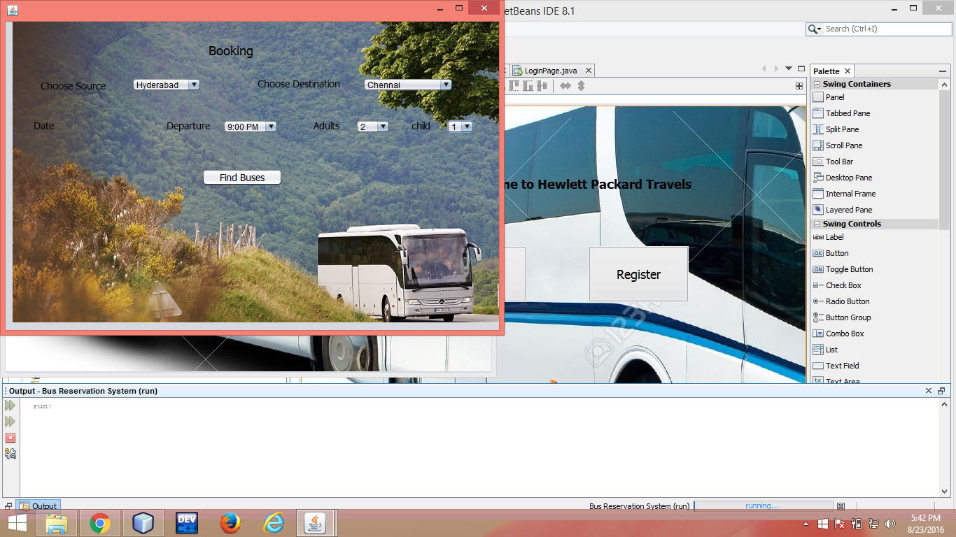

/*

* To change this license header, choose License Headers in Project Properties.

* To change this template file, choose Tools | Templates

* and open the template in the editor.

*/

package bus.reservation.system;

/**

*

* @author keerthi

*/

public class Booking extends javax.swing.JFrame {

/**

* Creates new form Booking

*/

public Booking() {

initComponents();

}

/**

* This method is called from within the constructor to initialize the form.

* WARNING: Do NOT modify this code. The content of this method is always

* regenerated by the Form Editor.

*/

@SuppressWarnings("unchecked")

// <editor-fold defaultstate="collapsed" desc="Generated Code">//GEN-BEGIN:initComponents

private void initComponents() {

jLabel7 = new javax.swing.JLabel();

jComboBox5 = new javax.swing.JComboBox<>();

jLabel8 = new javax.swing.JLabel();

jLabel9 = new javax.swing.JLabel();

jLabel10 = new javax.swing.JLabel();

jLabel11 = new javax.swing.JLabel();

jLabel13 = new javax.swing.JLabel();

jLabel1 = new javax.swing.JLabel();

jLabel2 = new javax.swing.JLabel();

jComboBox1 = new javax.swing.JComboBox<>();

jLabel3 = new javax.swing.JLabel();

jComboBox2 = new javax.swing.JComboBox<>();

jLabel4 = new javax.swing.JLabel();

jLabel5 = new javax.swing.JLabel();

jComboBox3 = new javax.swing.JComboBox<>();

jLabel6 = new javax.swing.JLabel();

jComboBox4 = new javax.swing.JComboBox<>();

jButton1 = new javax.swing.JButton();

jLabel12 = new javax.swing.JLabel();

jComboBox6 = new javax.swing.JComboBox<>();

jLabel14 = new javax.swing.JLabel();

jLabel7.setIcon(new javax.swing.ImageIcon(getClass().getResource("/bus/reservation/system/bus1.jpg"))); // NOI18N

jComboBox5.setModel(new javax.swing.DefaultComboBoxModel<>(new String[] { "Non-AC", "AC" }));

jLabel8.setFont(new java.awt.Font("Tahoma", 0, 14)); // NOI18N

jLabel8.setText("Type");

jLabel9.setIcon(new javax.swing.ImageIcon(getClass().getResource("/bus/reservation/system/bus3.jpg"))); // NOI18N

jLabel10.setIcon(new javax.swing.ImageIcon(getClass().getResource("/bus/reservation/system/bus3.jpg"))); // NOI18N

jLabel11.setIcon(new javax.swing.ImageIcon(getClass().getResource("/bus/reservation/system/bus4.jpg"))); // NOI18N

jLabel13.setIcon(new javax.swing.ImageIcon(getClass().getResource("/bus/reservation/system/01_Start_Tour-de-Culture_Parallax.jpg"))); // NOI18N

setDefaultCloseOperation(javax.swing.WindowConstants.EXIT_ON_CLOSE);

getContentPane().setLayout(null);

jLabel1.setFont(new java.awt.Font("Tahoma", 0, 18)); // NOI18N

jLabel1.setText("Booking ");

getContentPane().add(jLabel1);

jLabel1.setBounds(290, 30, 70, 22);

jLabel2.setFont(new java.awt.Font("Tahoma", 0, 14)); // NOI18N

jLabel2.setText("Choose Source");

getContentPane().add(jLabel2);

jLabel2.setBounds(50, 80, 110, 23);

jComboBox1.setModel(new javax.swing.DefaultComboBoxModel<>(new String[] { "select city", "Hyderabad", "Mumbai", "Chennai", "Banglore", "Vizag" }));

jComboBox1.addContainerListener(new java.awt.event.ContainerAdapter() {

public void componentAdded(java.awt.event.ContainerEvent evt) {

jComboBox1ComponentAdded(evt);

}

});

jComboBox1.addActionListener(new java.awt.event.ActionListener() {

public void actionPerformed(java.awt.event.ActionEvent evt) {

jComboBox1ActionPerformed(evt);

}

});

getContentPane().add(jComboBox1);

jComboBox1.setBounds(180, 80, 100, 20);

jLabel3.setFont(new java.awt.Font("Tahoma", 0, 14)); // NOI18N

jLabel3.setText("Choose Destination");

getContentPane().add(jLabel3);

jLabel3.setBounds(360, 80, 118, 17);

jComboBox2.setModel(new javax.swing.DefaultComboBoxModel<>(new String[] { "select destination", "Chennai", "Hyderabad", "Banglore", "Vizag", "Mumbai" }));

jComboBox2.addActionListener(new java.awt.event.ActionListener() {

public void actionPerformed(java.awt.event.ActionEvent evt) {

jComboBox2ActionPerformed(evt);

}

});

getContentPane().add(jComboBox2);

jComboBox2.setBounds(510, 80, 130, 20);

jLabel4.setFont(new java.awt.Font("Tahoma", 0, 14)); // NOI18N

jLabel4.setText("Date");

getContentPane().add(jLabel4);

jLabel4.setBounds(40, 140, 29, 17);

jLabel5.setFont(new java.awt.Font("Tahoma", 0, 14)); // NOI18N

jLabel5.setText("Adults");

getContentPane().add(jLabel5);

jLabel5.setBounds(440, 140, 37, 17);

jComboBox3.setModel(new javax.swing.DefaultComboBoxModel<>(new String[] { "1", "2", "3", "4", "5", "6", " " }));

jComboBox3.addActionListener(new java.awt.event.ActionListener() {

public void actionPerformed(java.awt.event.ActionEvent evt) {

jComboBox3ActionPerformed(evt);

}

});

getContentPane().add(jComboBox3);

jComboBox3.setBounds(500, 140, 50, 20);

jLabel6.setFont(new java.awt.Font("Tahoma", 0, 14)); // NOI18N

jLabel6.setText("child");

getContentPane().add(jLabel6);

jLabel6.setBounds(580, 140, 27, 17);

jComboBox4.setModel(new javax.swing.DefaultComboBoxModel<>(new String[] { "0", "1", "2", "3", "4" }));

jComboBox4.addActionListener(new java.awt.event.ActionListener() {

public void actionPerformed(java.awt.event.ActionEvent evt) {

jComboBox4ActionPerformed(evt);

}

});

getContentPane().add(jComboBox4);

jComboBox4.setBounds(630, 140, 40, 20);

jButton1.setFont(new java.awt.Font("Tahoma", 0, 14)); // NOI18N

jButton1.setText("Find Buses");

jButton1.addActionListener(new java.awt.event.ActionListener() {

public void actionPerformed(java.awt.event.ActionEvent evt) {

jButton1ActionPerformed(evt);

}

});

getContentPane().add(jButton1);

jButton1.setBounds(280, 210, 116, 25);

jLabel12.setFont(new java.awt.Font("Tahoma", 0, 14)); // NOI18N

jLabel12.setText("Departure");

getContentPane().add(jLabel12);

jLabel12.setBounds(230, 140, 70, 17);

jComboBox6.setModel(new javax.swing.DefaultComboBoxModel<>(new String[] { "6:00 PM", "9:00 PM", "9:00 AM", " " }));

getContentPane().add(jComboBox6);

jComboBox6.setBounds(310, 140, 80, 20);

jLabel14.setIcon(new javax.swing.ImageIcon(getClass().getResource("/bus/reservation/system/01_Start_Tour-de-Culture_Parallax.jpg"))); // NOI18N

getContentPane().add(jLabel14);

jLabel14.setBounds(10, 0, 720, 430);

pack();

}// </editor-fold>//GEN-END:initComponents

private void jComboBox1ActionPerformed(java.awt.event.ActionEvent evt) {//GEN-FIRST:event_jComboBox1ActionPerformed

// TODO add your handling code here:

}//GEN-LAST:event_jComboBox1ActionPerformed

private void jComboBox2ActionPerformed(java.awt.event.ActionEvent evt) {//GEN-FIRST:event_jComboBox2ActionPerformed

// TODO add your handling code here:

}//GEN-LAST:event_jComboBox2ActionPerformed

private void jComboBox1ComponentAdded(java.awt.event.ContainerEvent evt) {//GEN-FIRST:event_jComboBox1ComponentAdded

// TODO add your handling code here:

}//GEN-LAST:event_jComboBox1ComponentAdded

private void jComboBox3ActionPerformed(java.awt.event.ActionEvent evt) {//GEN-FIRST:event_jComboBox3ActionPerformed

// TODO add your handling code here:

}//GEN-LAST:event_jComboBox3ActionPerformed

private void jComboBox4ActionPerformed(java.awt.event.ActionEvent evt) {//GEN-FIRST:event_jComboBox4ActionPerformed

// TODO add your handling code here:

}//GEN-LAST:event_jComboBox4ActionPerformed

private void jButton1ActionPerformed(java.awt.event.ActionEvent evt) {//GEN-FIRST:event_jButton1ActionPerformed

// TODO add your handling code here:

FindBuses page=new FindBuses();

page.setVisible(true);

}//GEN-LAST:event_jButton1ActionPerformed

/**

* @param args the command line arguments

*/

public static void main(String args[]) {

/* Set the Nimbus look and feel */

//<editor-fold defaultstate="collapsed" desc=" Look and feel setting code (optional) ">

/* If Nimbus (introduced in Java SE 6) is not available, stay with the default look and feel.

* For details see http://download.oracle.com/javase/tutorial/uiswing/lookandfeel/plaf.html

*/

try {

for (javax.swing.UIManager.LookAndFeelInfo info : javax.swing.UIManager.getInstalledLookAndFeels()) {

if ("Nimbus".equals(info.getName())) {

javax.swing.UIManager.setLookAndFeel(info.getClassName());

break;

}

}

} catch (ClassNotFoundException ex) {

java.util.logging.Logger.getLogger(Booking.class.getName()).log(java.util.logging.Level.SEVERE, null, ex);

} catch (InstantiationException ex) {

java.util.logging.Logger.getLogger(Booking.class.getName()).log(java.util.logging.Level.SEVERE, null, ex);

} catch (IllegalAccessException ex) {

java.util.logging.Logger.getLogger(Booking.class.getName()).log(java.util.logging.Level.SEVERE, null, ex);

} catch (javax.swing.UnsupportedLookAndFeelException ex) {

java.util.logging.Logger.getLogger(Booking.class.getName()).log(java.util.logging.Level.SEVERE, null, ex);

}

//</editor-fold>

/* Create and display the form */

java.awt.EventQueue.invokeLater(new Runnable() {

public void run() {

new Booking().setVisible(true);

}

});

}

// Variables declaration - do not modify//GEN-BEGIN:variables

private javax.swing.JButton jButton1;

private javax.swing.JComboBox<String> jComboBox1;

private javax.swing.JComboBox<String> jComboBox2;

private javax.swing.JComboBox<String> jComboBox3;

private javax.swing.JComboBox<String> jComboBox4;

private javax.swing.JComboBox<String> jComboBox5;

private javax.swing.JComboBox<String> jComboBox6;

private javax.swing.JLabel jLabel1;

private javax.swing.JLabel jLabel10;

private javax.swing.JLabel jLabel11;

private javax.swing.JLabel jLabel12;

private javax.swing.JLabel jLabel13;

private javax.swing.JLabel jLabel14;

private javax.swing.JLabel jLabel2;

private javax.swing.JLabel jLabel3;

private javax.swing.JLabel jLabel4;

private javax.swing.JLabel jLabel5;

private javax.swing.JLabel jLabel6;

private javax.swing.JLabel jLabel7;

private javax.swing.JLabel jLabel8;

private javax.swing.JLabel jLabel9;

// End of variables declaration//GEN-END:variables

}

----------------------------------------------------------------------------------------------------------------------------

BUS RESERVATION SYSTEM.java:-

package bus.reservation.system;

/**

*

* @author Zibba

*/

public class BusReservationSystem {

/**

* @param args the command line arguments

*/

public static void main(String[] args) {

// TODO code application logic here

}

}

**FINDINGBUS.java:-**

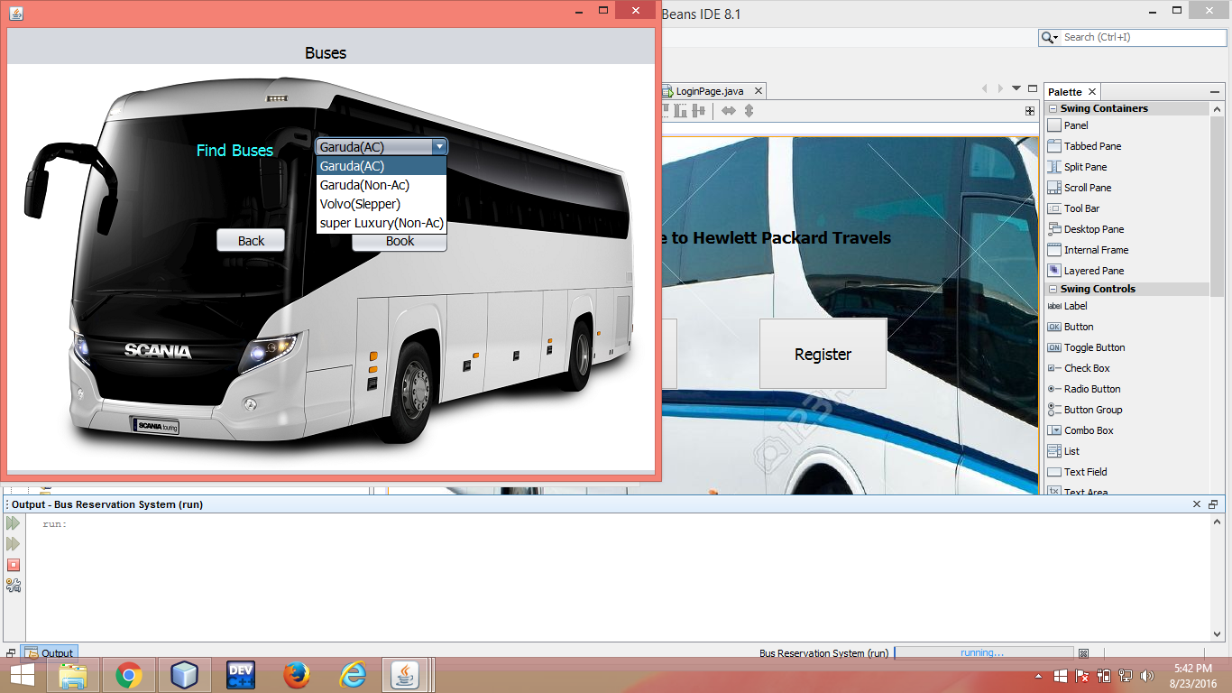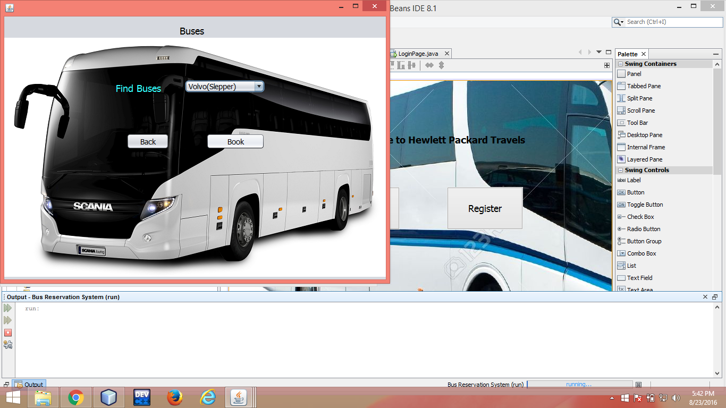

/*

* To change this license header, choose License Headers in Project Properties.

* To change this template file, choose Tools | Templates

* and open the template in the editor.

*/

package bus.reservation.system;

/**

*

* @author keerthi

*/

public class FindBuses extends javax.swing.JFrame {

/**

* Creates new form FindBuses

*/

public FindBuses() {

initComponents();

}

/**

* This method is called from within the constructor to initialize the form.

* WARNING: Do NOT modify this code. The content of this method is always

* regenerated by the Form Editor.

*/

@SuppressWarnings("unchecked")

// <editor-fold defaultstate="collapsed" desc="Generated Code">//GEN-BEGIN:initComponents

private void initComponents() {

jLabel2 = new javax.swing.JLabel();

jLabel5 = new javax.swing.JLabel();

jRadioButton3 = new javax.swing.JRadioButton();

jLabel4 = new javax.swing.JLabel();

jRadioButton2 = new javax.swing.JRadioButton();

jLabel3 = new javax.swing.JLabel();

jRadioButton1 = new javax.swing.JRadioButton();

jLabel7 = new javax.swing.JLabel();

jButton1 = new javax.swing.JButton();

jLabel1 = new javax.swing.JLabel();

jButton2 = new javax.swing.JButton();

jLabel6 = new javax.swing.JLabel();

jComboBox1 = new javax.swing.JComboBox<>();

jLabel8 = new javax.swing.JLabel();

jLabel2.setIcon(new javax.swing.ImageIcon(getClass().getResource("/bus/reservation/system/bus1.jpg"))); // NOI18N

jLabel5.setFont(new java.awt.Font("Tahoma", 0, 14)); // NOI18N

jLabel5.setText("Garuda(Non-AC)");

jRadioButton3.addActionListener(new java.awt.event.ActionListener() {

public void actionPerformed(java.awt.event.ActionEvent evt) {

jRadioButton3ActionPerformed(evt);

}

});

jLabel4.setFont(new java.awt.Font("Tahoma", 0, 14)); // NOI18N

jLabel4.setText("Volvo (slepper)");

jRadioButton2.addActionListener(new java.awt.event.ActionListener() {

public void actionPerformed(java.awt.event.ActionEvent evt) {

jRadioButton2ActionPerformed(evt);

}

});

jLabel3.setFont(new java.awt.Font("Tahoma", 0, 14)); // NOI18N

jLabel3.setText("Volvo Luxury(AC)");

jRadioButton1.addActionListener(new java.awt.event.ActionListener() {

public void actionPerformed(java.awt.event.ActionEvent evt) {

jRadioButton1ActionPerformed(evt);

}

});

jLabel7.setText("jLabel7");

setDefaultCloseOperation(javax.swing.WindowConstants.EXIT_ON_CLOSE);

getContentPane().setLayout(null);

jButton1.setFont(new java.awt.Font("Tahoma", 0, 14)); // NOI18N

jButton1.setText("Book");

jButton1.addActionListener(new java.awt.event.ActionListener() {

public void actionPerformed(java.awt.event.ActionEvent evt) {

jButton1ActionPerformed(evt);

}

});

getContentPane().add(jButton1);

jButton1.setBounds(380, 220, 110, 30);

jLabel1.setFont(new java.awt.Font("Tahoma", 0, 18)); // NOI18N

jLabel1.setText("Buses");

getContentPane().add(jLabel1);

jLabel1.setBounds(330, 20, 48, 14);

jButton2.setFont(new java.awt.Font("Tahoma", 0, 14)); // NOI18N

jButton2.setText("Back");

jButton2.addActionListener(new java.awt.event.ActionListener() {

public void actionPerformed(java.awt.event.ActionEvent evt) {

jButton2ActionPerformed(evt);

}

});

getContentPane().add(jButton2);

jButton2.setBounds(230, 220, 80, 30);

jLabel6.setFont(new java.awt.Font("Tahoma", 0, 18)); // NOI18N

jLabel6.setForeground(new java.awt.Color(51, 255, 255));

jLabel6.setText("Find Buses");

getContentPane().add(jLabel6);

jLabel6.setBounds(210, 120, 110, 30);

jComboBox1.setFont(new java.awt.Font("Tahoma", 0, 14)); // NOI18N

jComboBox1.setModel(new javax.swing.DefaultComboBoxModel<>(new String[] { "Garuda(AC)", "Garuda(Non-Ac)", "Volvo(Slepper)", "super Luxury(Non-Ac)" }));

jComboBox1.addActionListener(new java.awt.event.ActionListener() {

public void actionPerformed(java.awt.event.ActionEvent evt) {

jComboBox1ActionPerformed(evt);

}

});

getContentPane().add(jComboBox1);

jComboBox1.setBounds(340, 120, 150, 23);

jLabel8.setIcon(new javax.swing.ImageIcon(getClass().getResource("/bus/reservation/system/bus9.png"))); // NOI18N

getContentPane().add(jLabel8);

jLabel8.setBounds(0, 0, 740, 530);

pack();

}// </editor-fold>//GEN-END:initComponents

private void jButton1ActionPerformed(java.awt.event.ActionEvent evt) {//GEN-FIRST:event_jButton1ActionPerformed

// TODO add your handling code here:

pay page=new pay();

page.setVisible(true);

}//GEN-LAST:event_jButton1ActionPerformed

private void jButton2ActionPerformed(java.awt.event.ActionEvent evt) {//GEN-FIRST:event_jButton2ActionPerformed

// TODO add your handling code here:

Booking page=new Booking();

page.setVisible(true);

}//GEN-LAST:event_jButton2ActionPerformed

private void jRadioButton2ActionPerformed(java.awt.event.ActionEvent evt) {//GEN-FIRST:event_jRadioButton2ActionPerformed

// TODO add your handling code here:

}//GEN-LAST:event_jRadioButton2ActionPerformed

private void jRadioButton1ActionPerformed(java.awt.event.ActionEvent evt) {//GEN-FIRST:event_jRadioButton1ActionPerformed

// TODO add your handling code here:

}//GEN-LAST:event_jRadioButton1ActionPerformed

private void jRadioButton3ActionPerformed(java.awt.event.ActionEvent evt) {//GEN-FIRST:event_jRadioButton3ActionPerformed

// TODO add your handling code here:

}//GEN-LAST:event_jRadioButton3ActionPerformed

private void jComboBox1ActionPerformed(java.awt.event.ActionEvent evt) {//GEN-FIRST:event_jComboBox1ActionPerformed

// TODO add your handling code here:

}//GEN-LAST:event_jComboBox1ActionPerformed

/**

* @param args the command line arguments

*/

public static void main(String args[]) {

/* Set the Nimbus look and feel */

//<editor-fold defaultstate="collapsed" desc=" Look and feel setting code (optional) ">

/* If Nimbus (introduced in Java SE 6) is not available, stay with the default look and feel.

* For details see http://download.oracle.com/javase/tutorial/uiswing/lookandfeel/plaf.html

*/

try {

for (javax.swing.UIManager.LookAndFeelInfo info : javax.swing.UIManager.getInstalledLookAndFeels()) {

if ("Nimbus".equals(info.getName())) {

javax.swing.UIManager.setLookAndFeel(info.getClassName());

break;

}

}

} catch (ClassNotFoundException ex) {

java.util.logging.Logger.getLogger(FindBuses.class.getName()).log(java.util.logging.Level.SEVERE, null, ex);

} catch (InstantiationException ex) {

java.util.logging.Logger.getLogger(FindBuses.class.getName()).log(java.util.logging.Level.SEVERE, null, ex);

} catch (IllegalAccessException ex) {

java.util.logging.Logger.getLogger(FindBuses.class.getName()).log(java.util.logging.Level.SEVERE, null, ex);

} catch (javax.swing.UnsupportedLookAndFeelException ex) {

java.util.logging.Logger.getLogger(FindBuses.class.getName()).log(java.util.logging.Level.SEVERE, null, ex);

}

//</editor-fold>

/* Create and display the form */

java.awt.EventQueue.invokeLater(new Runnable() {

public void run() {

new FindBuses().setVisible(true);

}

});

}

// Variables declaration - do not modify//GEN-BEGIN:variables

private javax.swing.JButton jButton1;

private javax.swing.JButton jButton2;

private javax.swing.JComboBox<String> jComboBox1;

private javax.swing.JLabel jLabel1;

private javax.swing.JLabel jLabel2;

private javax.swing.JLabel jLabel3;

private javax.swing.JLabel jLabel4;

private javax.swing.JLabel jLabel5;

private javax.swing.JLabel jLabel6;

private javax.swing.JLabel jLabel7;

private javax.swing.JLabel jLabel8;

private javax.swing.JRadioButton jRadioButton1;

private javax.swing.JRadioButton jRadioButton2;

private javax.swing.JRadioButton jRadioButton3;

// End of variables declaration//GEN-END:variables

}

**LOGINPAGE.java:-**

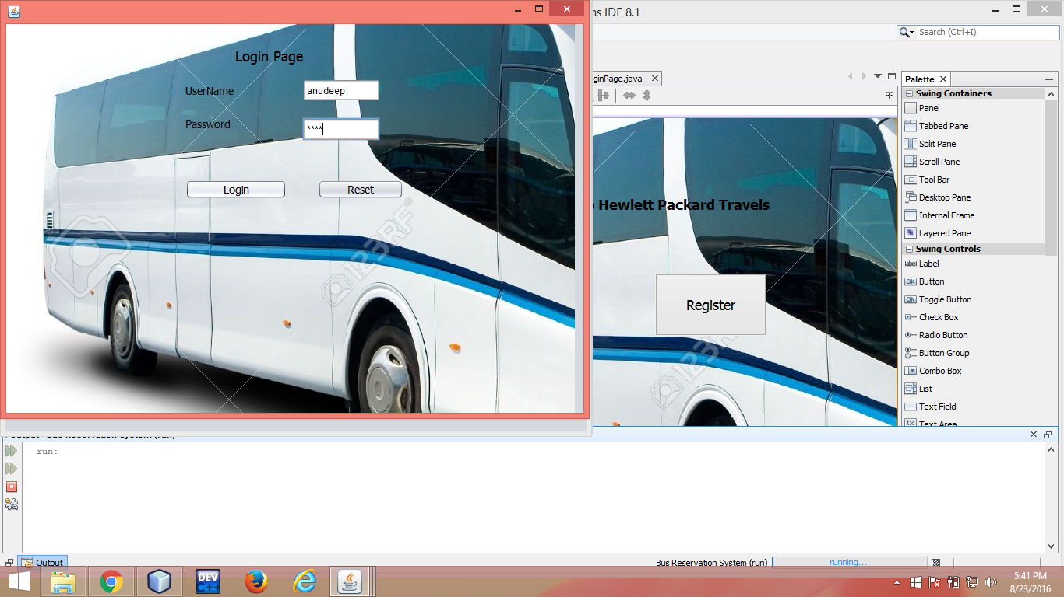

/*

* To change this license header, choose License Headers in Project Properties.

* To change this template file, choose Tools | Templates

* and open the template in the editor.

*/

package bus.reservation.system;

/**

*

* @author keerthi

*/

import java.io.*;

import javax.swing.*;

import java.awt.*;

import java.awt.event.*;

import java.sql.*;

import javax.swing.JOptionPane;

public class LoginPage extends javax.swing.JFrame {

/**

* Creates new form LoginPage

*/

public LoginPage() {

initComponents();

}

/**

* This method is called from within the constructor to initialize the form.

* WARNING: Do NOT modify this code. The content of this method is always

* regenerated by the Form Editor.

*/

@SuppressWarnings("unchecked")

// <editor-fold defaultstate="collapsed" desc="Generated Code">//GEN-BEGIN:initComponents

private void initComponents() {

jLabel4 = new javax.swing.JLabel();

jLabel1 = new javax.swing.JLabel();

jLabel2 = new javax.swing.JLabel();

jLabel3 = new javax.swing.JLabel();

jTextField1 = new javax.swing.JTextField();

jPasswordField1 = new javax.swing.JPasswordField();

jButton1 = new javax.swing.JButton();

jButton2 = new javax.swing.JButton();

jLabel5 = new javax.swing.JLabel();

jLabel4.setFont(new java.awt.Font("Tahoma", 0, 14)); // NOI18N

jLabel4.setIcon(new javax.swing.ImageIcon(getClass().getResource("/bus/reservation/system/bus3.jpg"))); // NOI18N

jLabel4.setToolTipText("");

setDefaultCloseOperation(javax.swing.WindowConstants.EXIT_ON_CLOSE);

getContentPane().setLayout(null);

jLabel1.setFont(new java.awt.Font("Tahoma", 0, 18)); // NOI18N

jLabel1.setText(" Login Page");

getContentPane().add(jLabel1);

jLabel1.setBounds(270, 30, 170, 22);

jLabel2.setFont(new java.awt.Font("Tahoma", 0, 14)); // NOI18N

jLabel2.setText("UserName");

getContentPane().add(jLabel2);

jLabel2.setBounds(230, 70, 80, 30);

jLabel3.setFont(new java.awt.Font("Tahoma", 0, 14)); // NOI18N

jLabel3.setText("Password");

getContentPane().add(jLabel3);

jLabel3.setBounds(230, 120, 80, 17);

jTextField1.addActionListener(new java.awt.event.ActionListener() {

public void actionPerformed(java.awt.event.ActionEvent evt) {

jTextField1ActionPerformed(evt);

}

});

getContentPane().add(jTextField1);

jTextField1.setBounds(380, 70, 100, 30);

jPasswordField1.addActionListener(new java.awt.event.ActionListener() {

public void actionPerformed(java.awt.event.ActionEvent evt) {

jPasswordField1ActionPerformed(evt);

}

});

getContentPane().add(jPasswordField1);

jPasswordField1.setBounds(380, 120, 100, 30);

jButton1.setFont(new java.awt.Font("Tahoma", 0, 14)); // NOI18N

jButton1.setText("Login");

jButton1.addActionListener(new java.awt.event.ActionListener() {

public void actionPerformed(java.awt.event.ActionEvent evt) {

jButton1ActionPerformed(evt);

}

});

getContentPane().add(jButton1);

jButton1.setBounds(230, 200, 130, 25);

jButton2.setFont(new java.awt.Font("Tahoma", 0, 14)); // NOI18N

jButton2.setText("Reset");

jButton2.addActionListener(new java.awt.event.ActionListener() {

public void actionPerformed(java.awt.event.ActionEvent evt) {

jButton2ActionPerformed(evt);

}

});

getContentPane().add(jButton2);

jButton2.setBounds(400, 200, 110, 25);

jLabel5.setIcon(new javax.swing.ImageIcon(getClass().getResource("/bus/reservation/system/bus1.jpg"))); // NOI18N

getContentPane().add(jLabel5);

jLabel5.setBounds(0, 0, 730, 500);

pack();

}// </editor-fold>//GEN-END:initComponents

private void jTextField1ActionPerformed(java.awt.event.ActionEvent evt) {//GEN-FIRST:event_jTextField1ActionPerformed

// TODO add your handling code here:

}//GEN-LAST:event_jTextField1ActionPerformed

private void jPasswordField1ActionPerformed(java.awt.event.ActionEvent evt) {//GEN-FIRST:event_jPasswordField1ActionPerformed

// TODO add your handling code here:

}//GEN-LAST:event_jPasswordField1ActionPerformed

private void jButton1ActionPerformed(java.awt.event.ActionEvent evt) {//GEN-FIRST:event_jButton1ActionPerformed

// TODO add your handling code here:

try

{

Class.forName("com.mysql.jdbc.Driver");

Connection con = DriverManager.getConnection("jdbc:mysql://localhost:3306/brs","root","h@r$h@01");

PreparedStatement pst = con.prepareStatement("select name,password from register where name=? and password=?");

pst.setString(1,jTextField1.getText());

pst.setString(2,jPasswordField1.getText());

ResultSet rs=pst.executeQuery();

if(rs.next())

{

Booking page=new Booking();

page.setVisible(true);

JLabel label = new JLabel("welcome");

page.getContentPane().add(label);

}

else

JOptionPane.showMessageDialog(null,"Incorrect details");

}

catch(Exception ex)

{

JOptionPane.showMessageDialog(null,ex.getMessage());

}

}//GEN-LAST:event_jButton1ActionPerformed

private void jButton2ActionPerformed(java.awt.event.ActionEvent evt) {//GEN-FIRST:event_jButton2ActionPerformed

// TODO add your handling code here:

jTextField1.setText(" ");

jPasswordField1.setText("");

}//GEN-LAST:event_jButton2ActionPerformed

/**

* @param args the command line arguments

*/

public static void main(String args[]) {

/* Set the Nimbus look and feel */

//<editor-fold defaultstate="collapsed" desc=" Look and feel setting code (optional) ">

/* If Nimbus (introduced in Java SE 6) is not available, stay with the default look and feel.

* For details see http://download.oracle.com/javase/tutorial/uiswing/lookandfeel/plaf.html

*/

try {

for (javax.swing.UIManager.LookAndFeelInfo info : javax.swing.UIManager.getInstalledLookAndFeels()) {

if ("Nimbus".equals(info.getName())) {

javax.swing.UIManager.setLookAndFeel(info.getClassName());

break;

}

}

} catch (ClassNotFoundException ex) {

java.util.logging.Logger.getLogger(LoginPage.class.getName()).log(java.util.logging.Level.SEVERE, null, ex);

} catch (InstantiationException ex) {

java.util.logging.Logger.getLogger(LoginPage.class.getName()).log(java.util.logging.Level.SEVERE, null, ex);

} catch (IllegalAccessException ex) {

java.util.logging.Logger.getLogger(LoginPage.class.getName()).log(java.util.logging.Level.SEVERE, null, ex);

} catch (javax.swing.UnsupportedLookAndFeelException ex) {

java.util.logging.Logger.getLogger(LoginPage.class.getName()).log(java.util.logging.Level.SEVERE, null, ex);

}

//</editor-fold>

/* Create and display the form */

java.awt.EventQueue.invokeLater(new Runnable() {

public void run() {

new LoginPage().setVisible(true);

}

});

}

// Variables declaration - do not modify//GEN-BEGIN:variables

private javax.swing.JButton jButton1;

private javax.swing.JButton jButton2;

private javax.swing.JLabel jLabel1;

private javax.swing.JLabel jLabel2;

private javax.swing.JLabel jLabel3;

private javax.swing.JLabel jLabel4;

private javax.swing.JLabel jLabel5;

private javax.swing.JPasswordField jPasswordField1;

private javax.swing.JTextField jTextField1;

// End of variables declaration//GEN-END:variables

}

-------------------------------------------------------------------------------------------------------------------------------------

**PAY.java:-**

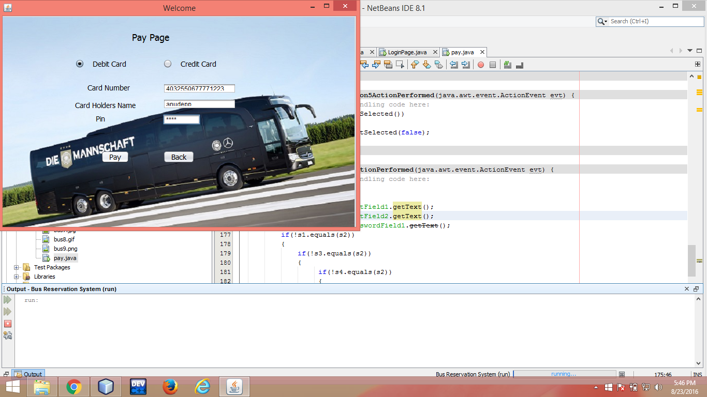

/*

* To change this license header, choose License Headers in Project Properties.

* To change this template file, choose Tools | Templates

* And open the template in the editor.

*/

package bus.reservation.system;

/**

*

* @author keerthi

*/import java.sql.Connection;

import java.sql.DriverManager;

import java.sql.PreparedStatement;

import java.sql.ResultSet;

import javax.swing.JLabel;

import javax.swing.JOptionPane;

/**

*

* @author admin'

*/

public class pay extends javax.swing.JFrame {

/**

* Creates new form pay

*/

public pay() {

initComponents();

setDefaultCloseOperation(javax.swing.WindowConstants.DISPOSE_ON_CLOSE);

setTitle("Welcome");

setSize(1920,1080);

}

/**

* This method is called from within the constructor to initialize the form.

* WARNING: Do NOT modify this code. The content of this method is always

* regenerated by the Form Editor.

*/

@SuppressWarnings("unchecked")

// <editor-fold defaultstate="collapsed" desc="Generated Code">//GEN-BEGIN:initComponents

private void initComponents() {

jRadioButton1 = new javax.swing.JRadioButton();

jRadioButton2 = new javax.swing.JRadioButton();

jRadioButton3 = new javax.swing.JRadioButton();

jButton1 = new javax.swing.JButton();

jButton3 = new javax.swing.JButton();

jLabel6 = new javax.swing.JLabel();

jLabel7 = new javax.swing.JLabel();

jRadioButton4 = new javax.swing.JRadioButton();

jRadioButton5 = new javax.swing.JRadioButton();

jLabel1 = new javax.swing.JLabel();

jLabel2 = new javax.swing.JLabel();

jTextField1 = new javax.swing.JTextField();

jLabel3 = new javax.swing.JLabel();

jPasswordField1 = new javax.swing.JPasswordField();

jButton2 = new javax.swing.JButton();

jDateChooser1 = new com.toedter.calendar.JDateChooser();

jLabel4 = new javax.swing.JLabel();

jLabel5 = new javax.swing.JLabel();

jTextField2 = new javax.swing.JTextField();

jButton4 = new javax.swing.JButton();

jLabel8 = new javax.swing.JLabel();

jRadioButton1.setText("jRadioButton1");

jRadioButton2.setText("jRadioButton2");

jRadioButton3.setText("jRadioButton3");

jButton1.setText("jButton1");

jButton3.setText("jButton3");

jLabel6.setIcon(new javax.swing.ImageIcon(getClass().getResource("/bus/reservation/system/bus1.jpg"))); // NOI18N

jLabel7.setIcon(new javax.swing.ImageIcon(getClass().getResource("/bus/reservation/system/01-Mercedes-Benz-Sport-DFB-Travego-M-German-National-Team-1180x686.jpg"))); // NOI18N

setDefaultCloseOperation(javax.swing.WindowConstants.EXIT_ON_CLOSE);

getContentPane().setLayout(null);

jRadioButton4.setFont(new java.awt.Font("Tahoma", 0, 14)); // NOI18N

jRadioButton4.setText(" Debit Card");

jRadioButton4.addActionListener(new java.awt.event.ActionListener() {

public void actionPerformed(java.awt.event.ActionEvent evt) {

jRadioButton4ActionPerformed(evt);

}

});

getContentPane().add(jRadioButton4);

jRadioButton4.setBounds(140, 80, 105, 25);

jRadioButton5.setFont(new java.awt.Font("Tahoma", 0, 14)); // NOI18N

jRadioButton5.setText(" Credit Card");

jRadioButton5.addActionListener(new java.awt.event.ActionListener() {

public void actionPerformed(java.awt.event.ActionEvent evt) {

jRadioButton5ActionPerformed(evt);

}

});

getContentPane().add(jRadioButton5);

jRadioButton5.setBounds(310, 80, 107, 25);

jLabel1.setFont(new java.awt.Font("Tahoma", 0, 18)); // NOI18N

jLabel1.setText("Pay Page");

getContentPane().add(jLabel1);

jLabel1.setBounds(250, 30, 79, 22);

jLabel2.setFont(new java.awt.Font("Tahoma", 0, 14)); // NOI18N

jLabel2.setText(" Card Number");

getContentPane().add(jLabel2);

jLabel2.setBounds(160, 130, 86, 17);

jTextField1.addActionListener(new java.awt.event.ActionListener() {

public void actionPerformed(java.awt.event.ActionEvent evt) {

jTextField1ActionPerformed(evt);

}

});

getContentPane().add(jTextField1);

jTextField1.setBounds(310, 130, 141, 20);

jLabel3.setFont(new java.awt.Font("Tahoma", 0, 14)); // NOI18N

jLabel3.setText("Pin");

getContentPane().add(jLabel3);

jLabel3.setBounds(180, 190, 56, 17);

getContentPane().add(jPasswordField1);

jPasswordField1.setBounds(310, 190, 72, 20);

jButton2.setFont(new java.awt.Font("Tahoma", 0, 14)); // NOI18N

jButton2.setText("Pay");

jButton2.addActionListener(new java.awt.event.ActionListener() {

public void actionPerformed(java.awt.event.ActionEvent evt) {

jButton2ActionPerformed(evt);

}

});

getContentPane().add(jButton2);

jButton2.setBounds(190, 260, 55, 25);

getContentPane().add(jDateChooser1);

jDateChooser1.setBounds(310, 220, 91, 20);

jLabel4.setFont(new java.awt.Font("Tahoma", 0, 14)); // NOI18N

jLabel4.setForeground(new java.awt.Color(51, 102, 255));

jLabel4.setText("Expiry Date");

getContentPane().add(jLabel4);

jLabel4.setBounds(170, 220, 86, 17);

jLabel5.setFont(new java.awt.Font("Tahoma", 0, 14)); // NOI18N

jLabel5.setText("Card Holders Name");

getContentPane().add(jLabel5);

jLabel5.setBounds(140, 160, 117, 24);

getContentPane().add(jTextField2);

jTextField2.setBounds(310, 160, 141, 20);

jButton4.setFont(new java.awt.Font("Tahoma", 0, 14)); // NOI18N

jButton4.setText("Back");

jButton4.addActionListener(new java.awt.event.ActionListener() {

public void actionPerformed(java.awt.event.ActionEvent evt) {

jButton4ActionPerformed(evt);

}

});

getContentPane().add(jButton4);

jButton4.setBounds(310, 260, 61, 25);

jLabel8.setIcon(new javax.swing.ImageIcon(getClass().getResource("/bus/reservation/system/01-Mercedes-Benz-Sport-DFB-Travego-M-German-National-Team-1180x686.jpg"))); // NOI18N

getContentPane().add(jLabel8);

jLabel8.setBounds(0, -10, 680, 430);

pack();

}// </editor-fold>//GEN-END:initComponents

private void jRadioButton5ActionPerformed(java.awt.event.ActionEvent evt) {//GEN-FIRST:event_jRadioButton5ActionPerformed

// TODO add your handling code here:

if(jRadioButton5.isSelected())

{

jRadioButton4.setSelected(false);

}

}//GEN-LAST:event_jRadioButton5ActionPerformed

private void jButton2ActionPerformed(java.awt.event.ActionEvent evt) {//GEN-FIRST:event_jButton2ActionPerformed

// TODO add your handling code here:

try{

String s2="";

String s1=jTextField1.getText();

String s3=jTextField2.getText();

String s4=jPasswordField1.getText();

if(!s1.equals(s2))

{

if(!s3.equals(s2))

{

if(!s4.equals(s2))

{

ThankYou page=new ThankYou();

page.setVisible(true);

}}

}}

catch(Exception ex)

{

JOptionPane.showMessageDialog(null,ex.getMessage());

}

}//GEN-LAST:event_jButton2ActionPerformed

private void jButton4ActionPerformed(java.awt.event.ActionEvent evt) {//GEN-FIRST:event_jButton4ActionPerformed

// TODO add your handling code here:

Booking page=new Booking();

page.setVisible(true);

}//GEN-LAST:event_jButton4ActionPerformed

private void jRadioButton4ActionPerformed(java.awt.event.ActionEvent evt) {//GEN-FIRST:event_jRadioButton4ActionPerformed

// TODO add your handling code here:

if(jRadioButton4.isSelected())

{

jRadioButton5.setSelected(false);

}

}//GEN-LAST:event_jRadioButton4ActionPerformed

private void jTextField1ActionPerformed(java.awt.event.ActionEvent evt) {//GEN-FIRST:event_jTextField1ActionPerformed

// TODO add your handling code here:

}//GEN-LAST:event_jTextField1ActionPerformed

/**

* @param args the command line arguments

*/

public static void main(String args[]) {

/* Set the Nimbus look and feel */

//<editor-fold defaultstate="collapsed" desc=" Look and feel setting code (optional) ">

/* If Nimbus (introduced in Java SE 6) is not available, stay with the default look and feel.

* For details see http://download.oracle.com/javase/tutorial/uiswing/lookandfeel/plaf.html

*/

try {

for (javax.swing.UIManager.LookAndFeelInfo info : javax.swing.UIManager.getInstalledLookAndFeels()) {

if ("Nimbus".equals(info.getName())) {

javax.swing.UIManager.setLookAndFeel(info.getClassName());

break;

}

}

} catch (ClassNotFoundException ex) {

java.util.logging.Logger.getLogger(pay.class.getName()).log(java.util.logging.Level.SEVERE, null, ex);

} catch (InstantiationException ex) {

java.util.logging.Logger.getLogger(pay.class.getName()).log(java.util.logging.Level.SEVERE, null, ex);

} catch (IllegalAccessException ex) {

java.util.logging.Logger.getLogger(pay.class.getName()).log(java.util.logging.Level.SEVERE, null, ex);

} catch (javax.swing.UnsupportedLookAndFeelException ex) {

java.util.logging.Logger.getLogger(pay.class.getName()).log(java.util.logging.Level.SEVERE, null, ex);

}

//</editor-fold>

/* Create and display the form */

java.awt.EventQueue.invokeLater(new Runnable() {

public void run() {

new pay().setVisible(true);

}

});

}

// Variables declaration - do not modify//GEN-BEGIN:variables

private javax.swing.JButton jButton1;

private javax.swing.JButton jButton2;

private javax.swing.JButton jButton3;

private javax.swing.JButton jButton4;

private com.toedter.calendar.JDateChooser jDateChooser1;

private javax.swing.JLabel jLabel1;

private javax.swing.JLabel jLabel2;

private javax.swing.JLabel jLabel3;

private javax.swing.JLabel jLabel4;

private javax.swing.JLabel jLabel5;

private javax.swing.JLabel jLabel6;

private javax.swing.JLabel jLabel7;

private javax.swing.JLabel jLabel8;

private javax.swing.JPasswordField jPasswordField1;

private javax.swing.JRadioButton jRadioButton1;

private javax.swing.JRadioButton jRadioButton2;

private javax.swing.JRadioButton jRadioButton3;

private javax.swing.JRadioButton jRadioButton4;

private javax.swing.JRadioButton jRadioButton5;

private javax.swing.JTextField jTextField1;

private javax.swing.JTextField jTextField2;

// End of variables declaration//GEN-END:variables

}

-------------------------------------------------------------------------------------------------------------------------------------

**REGISTRATION.java:-**

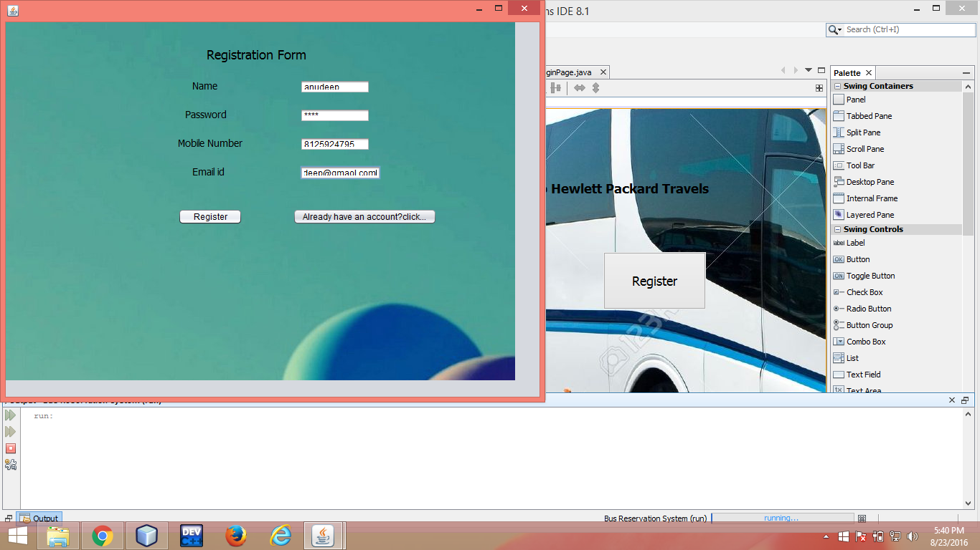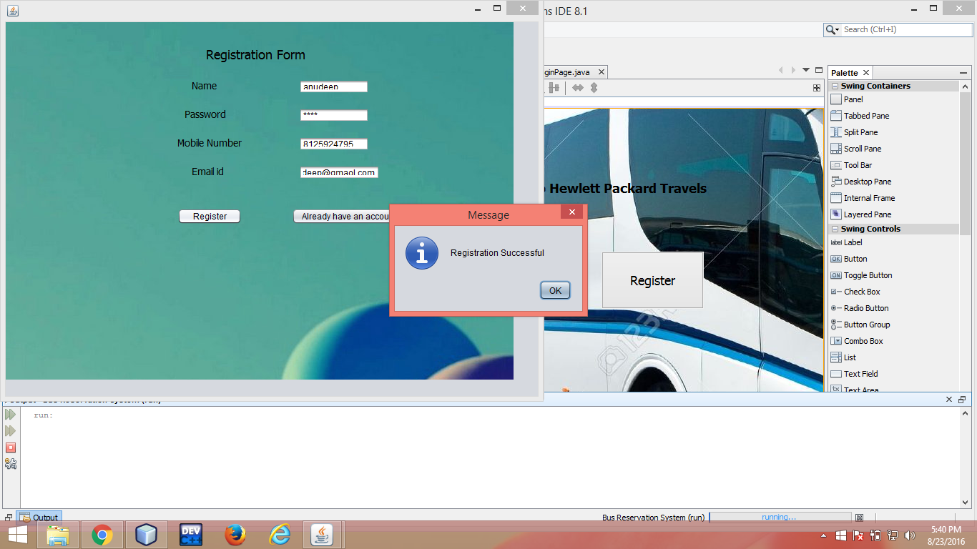

/*

* To change this license header, choose License Headers in Project Properties.

* To change this template file, choose Tools | Templates

* and open the template in the editor.

*/

package bus.reservation.system;

/**

*

* @author keerthi */

import javax.swing.*;

import java.awt.*;

import java.awt.event.*;

import java.sql.*;

import javax.swing.JOptionPane;

public class Registration extends javax.swing.JFrame {

/**

* Creates new form Registration

*/

public Registration() {

initComponents();

}

/**

* This method is called from within the constructor to initialize the form.

* WARNING: Do NOT modify this code. The content of this method is always

* regenerated by the Form Editor.

*/

@SuppressWarnings("unchecked")

// <editor-fold defaultstate="collapsed" desc="Generated Code">//GEN-BEGIN:initComponents

private void initComponents() {

jLabel5 = new javax.swing.JLabel();

jLabel7 = new javax.swing.JLabel();

jLabel2 = new javax.swing.JLabel();

jLabel1 = new javax.swing.JLabel();

jTextField1 = new javax.swing.JTextField();

jLabel3 = new javax.swing.JLabel();

jPasswordField1 = new javax.swing.JPasswordField();

jLabel4 = new javax.swing.JLabel();

jTextField2 = new javax.swing.JTextField();

jLabel6 = new javax.swing.JLabel();

jTextField3 = new javax.swing.JTextField();

jButton1 = new javax.swing.JButton();

jButton2 = new javax.swing.JButton();

jLabel8 = new javax.swing.JLabel();

jLabel5.setText("jLabel5");

jLabel7.setIcon(new javax.swing.ImageIcon(getClass().getResource("/bus/reservation/system/bus5.png"))); // NOI18N

setDefaultCloseOperation(javax.swing.WindowConstants.EXIT_ON_CLOSE);

getContentPane().setLayout(null);

jLabel2.setFont(new java.awt.Font("Tahoma", 0, 18)); // NOI18N

jLabel2.setText("Registration Form");

getContentPane().add(jLabel2);

jLabel2.setBounds(280, 30, 139, 30);

jLabel1.setFont(new java.awt.Font("Tahoma", 0, 14)); // NOI18N

jLabel1.setText("Name");

getContentPane().add(jLabel1);

jLabel1.setBounds(260, 80, 35, 17);

getContentPane().add(jTextField1);

jTextField1.setBounds(410, 80, 98, 20);

jLabel3.setFont(new java.awt.Font("Tahoma", 0, 14)); // NOI18N

jLabel3.setText("Password");

getContentPane().add(jLabel3);

jLabel3.setBounds(250, 120, 58, 17);

getContentPane().add(jPasswordField1);

jPasswordField1.setBounds(410, 120, 98, 20);

jLabel4.setFont(new java.awt.Font("Tahoma", 0, 14)); // NOI18N

jLabel4.setText("Mobile Number");

getContentPane().add(jLabel4);

jLabel4.setBounds(240, 160, 90, 17);

getContentPane().add(jTextField2);

jTextField2.setBounds(410, 160, 98, 20);

jLabel6.setFont(new java.awt.Font("Tahoma", 0, 14)); // NOI18N

jLabel6.setText("Email id");

getContentPane().add(jLabel6);

jLabel6.setBounds(260, 200, 45, 17);

jTextField3.addActionListener(new java.awt.event.ActionListener() {

public void actionPerformed(java.awt.event.ActionEvent evt) {

jTextField3ActionPerformed(evt);

}

});

getContentPane().add(jTextField3);

jTextField3.setBounds(410, 200, 113, 20);

jButton1.setText("Register");

jButton1.addActionListener(new java.awt.event.ActionListener() {

public void actionPerformed(java.awt.event.ActionEvent evt) {

jButton1ActionPerformed(evt);

}

});

getContentPane().add(jButton1);

jButton1.setBounds(240, 260, 90, 23);

jButton2.setText("Already have an account?click here");

jButton2.addActionListener(new java.awt.event.ActionListener() {

public void actionPerformed(java.awt.event.ActionEvent evt) {

jButton2ActionPerformed(evt);

}

});

getContentPane().add(jButton2);

jButton2.setBounds(400, 260, 201, 23);

jLabel8.setIcon(new javax.swing.ImageIcon(getClass().getResource("/bus/reservation/system/bus7.jpg"))); // NOI18N

getContentPane().add(jLabel8);

jLabel8.setBounds(-10, 0, 720, 500);

pack();

}// </editor-fold>//GEN-END:initComponents

private void jButton1ActionPerformed(java.awt.event.ActionEvent evt) {//GEN-FIRST:event_jButton1ActionPerformed

// TODO add your handling code here:

try

{

Class.forName("com.mysql.jdbc.Driver");

Connection con = DriverManager.getConnection("jdbc:mysql://localhost:3306/brs","root","h@r$h@01");

PreparedStatement pst=con.prepareStatement("insert into register values(?,?,?,?)");

String s1=jTextField1.getText();

String s2=jPasswordField1.getText();

String s3=jTextField2.getText();

String s4=jTextField3.getText();

pst.setString(1,s1);

pst.setString(2,s2);

pst.setString(3,s3);

pst.setString(4,s4);

int status = pst.executeUpdate();

if(status>0)

{

JOptionPane.showMessageDialog(null,"Registration Successful");

LoginPage page=new LoginPage();

page.setVisible(true);

}

}

catch(Exception ex)

{

JOptionPane.showMessageDialog(null,ex.getMessage());

}

}//GEN-LAST:event_jButton1ActionPerformed

private void jButton2ActionPerformed(java.awt.event.ActionEvent evt) {//GEN-FIRST:event_jButton2ActionPerformed

// TODO add your handling code here:

LoginPage page=new LoginPage();

page.setVisible(true);

}//GEN-LAST:event_jButton2ActionPerformed

private void jTextField3ActionPerformed(java.awt.event.ActionEvent evt) {//GEN-FIRST:event_jTextField3ActionPerformed

// TODO add your handling code here:

}//GEN-LAST:event_jTextField3ActionPerformed

/**

* @param args the command line arguments

*/

public static void main(String args[]) {

/* Set the Nimbus look and feel */

//<editor-fold defaultstate="collapsed" desc=" Look and feel setting code (optional) ">

/* If Nimbus (introduced in Java SE 6) is not available, stay with the default look and feel.

* For details see http://download.oracle.com/javase/tutorial/uiswing/lookandfeel/plaf.html

*/

try {

for (javax.swing.UIManager.LookAndFeelInfo info : javax.swing.UIManager.getInstalledLookAndFeels()) {

if ("Nimbus".equals(info.getName())) {

javax.swing.UIManager.setLookAndFeel(info.getClassName());

break;

}

}

} catch (ClassNotFoundException ex) {

java.util.logging.Logger.getLogger(Registration.class.getName()).log(java.util.logging.Level.SEVERE, null, ex);

} catch (InstantiationException ex) {

java.util.logging.Logger.getLogger(Registration.class.getName()).log(java.util.logging.Level.SEVERE, null, ex);

} catch (IllegalAccessException ex) {

java.util.logging.Logger.getLogger(Registration.class.getName()).log(java.util.logging.Level.SEVERE, null, ex);

} catch (javax.swing.UnsupportedLookAndFeelException ex) {

java.util.logging.Logger.getLogger(Registration.class.getName()).log(java.util.logging.Level.SEVERE, null, ex);

}

//</editor-fold>

/* Create and display the form */

java.awt.EventQueue.invokeLater(new Runnable() {

public void run() {

new Registration().setVisible(true);

}

});

}

// Variables declaration - do not modify//GEN-BEGIN:variables

private javax.swing.JButton jButton1;

private javax.swing.JButton jButton2;

private javax.swing.JLabel jLabel1;

private javax.swing.JLabel jLabel2;

private javax.swing.JLabel jLabel3;

private javax.swing.JLabel jLabel4;

private javax.swing.JLabel jLabel5;

private javax.swing.JLabel jLabel6;

private javax.swing.JLabel jLabel7;

private javax.swing.JLabel jLabel8;

private javax.swing.JPasswordField jPasswordField1;

private javax.swing.JTextField jTextField1;

private javax.swing.JTextField jTextField2;

private javax.swing.JTextField jTextField3;

// End of variables declaration//GEN-END:variables

}

------------------------------------------------------------------------------------------------------------------------------------------

**THANKYOU.java**:-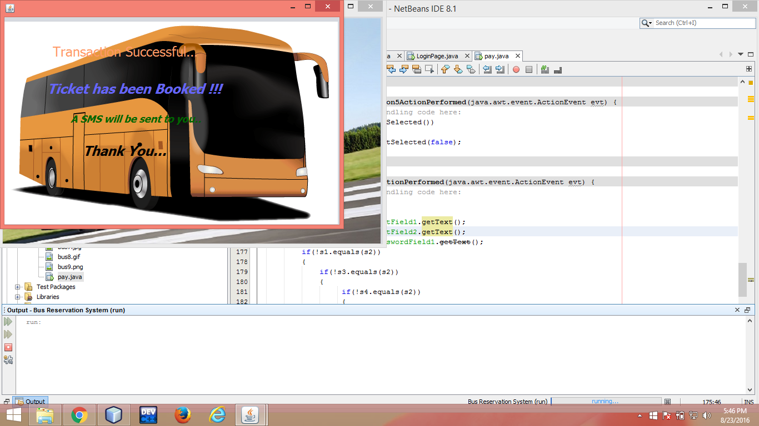

/*

* To change this license header, choose License Headers in Project Properties.

* To change this template file, choose Tools | Templates

* and open the template in the editor.

*/

package bus.reservation.system;

/**

*

* @author keerthi

*/

public class ThankYou extends javax.swing.JFrame {

/**

* Creates new form ThankYou

*/

public ThankYou() {

initComponents();

}

/**

* This method is called from within the constructor to initialize the form.

* WARNING: Do NOT modify this code. The content of this method is always

* regenerated by the Form Editor.

*/

@SuppressWarnings("unchecked")

// <editor-fold defaultstate="collapsed" desc="Generated Code">//GEN-BEGIN:initComponents

private void initComponents() {

jLabel1 = new javax.swing.JLabel();

jLabel2 = new javax.swing.JLabel();

jLabel3 = new javax.swing.JLabel();

jLabel4 = new javax.swing.JLabel();

jLabel5 = new javax.swing.JLabel();

setDefaultCloseOperation(javax.swing.WindowConstants.EXIT_ON_CLOSE);

getContentPane().setLayout(null);

jLabel1.setFont(new java.awt.Font("Tahoma", 3, 24)); // NOI18N

jLabel1.setForeground(new java.awt.Color(102, 102, 255));

jLabel1.setText("Ticket has been Booked !!!");

getContentPane().add(jLabel1);

jLabel1.setBounds(77, 114, 336, 29);

jLabel2.setFont(new java.awt.Font("Tahoma", 0, 24)); // NOI18N

jLabel2.setForeground(new java.awt.Color(255, 153, 102));

jLabel2.setText("Transaction Successful...");

getContentPane().add(jLabel2);

jLabel2.setBounds(87, 47, 298, 29);

jLabel3.setFont(new java.awt.Font("Tahoma", 3, 18)); // NOI18N

jLabel3.setForeground(new java.awt.Color(0, 102, 0));

jLabel3.setText("A SMS will be sent to you..");

getContentPane().add(jLabel3);

jLabel3.setBounds(119, 172, 235, 22);

jLabel4.setFont(new java.awt.Font("Tahoma", 3, 24)); // NOI18N

jLabel4.setText("Thank You...");

jLabel4.setCursor(new java.awt.Cursor(java.awt.Cursor.DEFAULT_CURSOR));

getContentPane().add(jLabel4);

jLabel4.setBounds(141, 226, 150, 29);

jLabel5.setIcon(new javax.swing.ImageIcon(getClass().getResource("/bus/reservation/system/bus5.png"))); // NOI18N

getContentPane().add(jLabel5);

jLabel5.setBounds(0, 0, 600, 380);

pack();

}// </editor-fold>//GEN-END:initComponents

/**

* @param args the command line arguments

*/

public static void main(String args[]) {

/* Set the Nimbus look and feel */

//<editor-fold defaultstate="collapsed" desc=" Look and feel setting code (optional) ">

/* If Nimbus (introduced in Java SE 6) is not available, stay with the default look and feel.

* For details see http://download.oracle.com/javase/tutorial/uiswing/lookandfeel/plaf.html

*/

try {

for (javax.swing.UIManager.LookAndFeelInfo info : javax.swing.UIManager.getInstalledLookAndFeels()) {

if ("Nimbus".equals(info.getName())) {

javax.swing.UIManager.setLookAndFeel(info.getClassName());

break;

}

}

} catch (ClassNotFoundException ex) {

java.util.logging.Logger.getLogger(ThankYou.class.getName()).log(java.util.logging.Level.SEVERE, null, ex);

} catch (InstantiationException ex) {

java.util.logging.Logger.getLogger(ThankYou.class.getName()).log(java.util.logging.Level.SEVERE, null, ex);

} catch (IllegalAccessException ex) {

java.util.logging.Logger.getLogger(ThankYou.class.getName()).log(java.util.logging.Level.SEVERE, null, ex);

} catch (javax.swing.UnsupportedLookAndFeelException ex) {

java.util.logging.Logger.getLogger(ThankYou.class.getName()).log(java.util.logging.Level.SEVERE, null, ex);

}

//</editor-fold>

/* Create and display the form */

java.awt.EventQueue.invokeLater(new Runnable() {

public void run() {

new ThankYou().setVisible(true);

}

});

}

// Variables declaration - do not modify//GEN-BEGIN:variables

private javax.swing.JLabel jLabel1;

private javax.swing.JLabel jLabel2;

private javax.swing.JLabel jLabel3;

private javax.swing.JLabel jLabel4;

private javax.swing.JLabel jLabel5;

// End of variables declaration//GEN-END:variables

}

----------------------------------------------------------------------------------------------------------------------------------

**WELCOME.java:-**

/*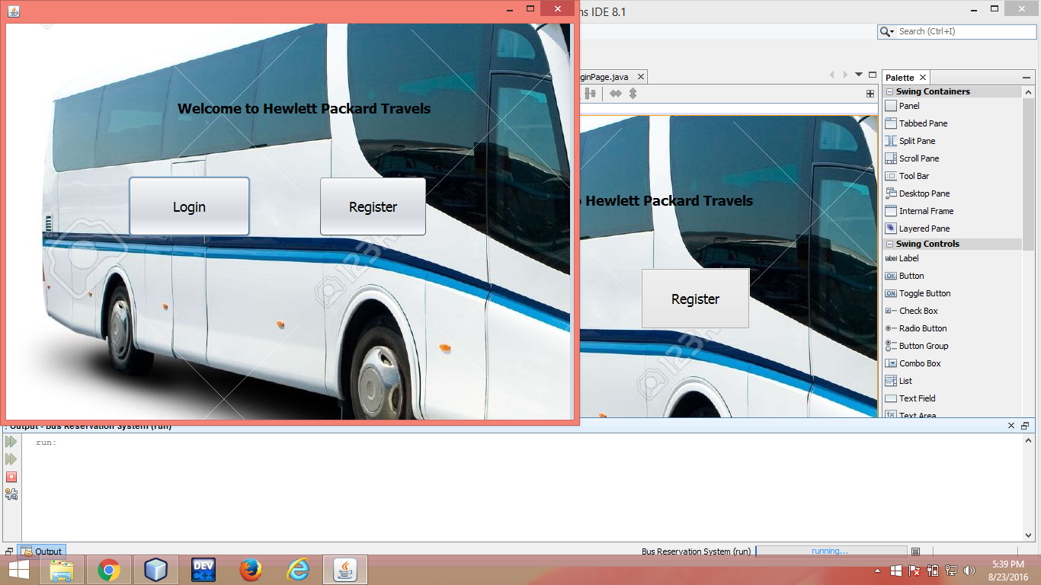

* To change this license header, choose License Headers in Project Properties.

 * and open the template in the editor.

*/

package bus.reservation.system;

/**

*

* @author keerthi

*/

public class Welcome extends javax.swing.JFrame {

/**

* Creates new form Welcome

*/

public Welcome() {

initComponents();

}

/**

* This method is called from within the constructor to initialize the form.

* WARNING: Do NOT modify this code. The content of this method is always

* regenerated by the Form Editor.

*/

@SuppressWarnings("unchecked")

// <editor-fold defaultstate="collapsed" desc="Generated Code">//GEN-BEGIN:initComponents

private void initComponents() {

jLabel1 = new javax.swing.JLabel();

jButton1 = new javax.swing.JButton();

jButton2 = new javax.swing.JButton();

jLabel2 = new javax.swing.JLabel();

setDefaultCloseOperation(javax.swing.WindowConstants.EXIT_ON_CLOSE);

getContentPane().setLayout(null);

jLabel1.setFont(new java.awt.Font("Tahoma", 1, 18)); // NOI18N

jLabel1.setText(" Welcome to Hewlett Packard Travels");

getContentPane().add(jLabel1);

jLabel1.setBounds(200, 80, 359, 63);

jButton1.setFont(new java.awt.Font("Tahoma", 0, 18)); // NOI18N

jButton1.setText("Login");

jButton1.addActionListener(new java.awt.event.ActionListener() {

public void actionPerformed(java.awt.event.ActionEvent evt) {

jButton1ActionPerformed(evt);

}

});

getContentPane().add(jButton1);

jButton1.setBounds(160, 200, 161, 80);

jButton2.setFont(new java.awt.Font("Tahoma", 0, 18)); // NOI18N

jButton2.setText("Register");

jButton2.addActionListener(new java.awt.event.ActionListener() {

public void actionPerformed(java.awt.event.ActionEvent evt) {

jButton2ActionPerformed(evt);

}

});

getContentPane().add(jButton2);

jButton2.setBounds(410, 200, 143, 80);

jLabel2.setIcon(new javax.swing.ImageIcon(getClass().getResource("/bus/reservation/system/bus1.jpg"))); // NOI18N

jLabel2.setToolTipText("");

getContentPane().add(jLabel2);

jLabel2.setBounds(0, 0, 740, 520);

pack();

}// </editor-fold>//GEN-END:initComponents

private void jButton1ActionPerformed(java.awt.event.ActionEvent evt) {//GEN-FIRST:event_jButton1ActionPerformed

// TODO add your handling code here:

LoginPage page=new LoginPage();

page.setVisible(true);

}//GEN-LAST:event_jButton1ActionPerformed

private void jButton2ActionPerformed(java.awt.event.ActionEvent evt) {//GEN-FIRST:event_jButton2ActionPerformed

// TODO add your handling code here:

Registration page=new Registration();

page.setVisible(true);

}//GEN-LAST:event_jButton2ActionPerformed

/**

* @param args the command line arguments

*/

public static void main(String args[]) {

/* Set the Nimbus look and feel */

//<editor-fold defaultstate="collapsed" desc=" Look and feel setting code (optional) ">

/* If Nimbus (introduced in Java SE 6) is not available, stay with the default look and feel.

* For details see http://download.oracle.com/javase/tutorial/uiswing/lookandfeel/plaf.html

*/

try {

for (javax.swing.UIManager.LookAndFeelInfo info : javax.swing.UIManager.getInstalledLookAndFeels()) {

if ("Nimbus".equals(info.getName())) {

javax.swing.UIManager.setLookAndFeel(info.getClassName());

break;

}

}

} catch (ClassNotFoundException ex) {

java.util.logging.Logger.getLogger(Welcome.class.getName()).log(java.util.logging.Level.SEVERE, null, ex);

} catch (InstantiationException ex) {

java.util.logging.Logger.getLogger(Welcome.class.getName()).log(java.util.logging.Level.SEVERE, null, ex);

} catch (IllegalAccessException ex) {

java.util.logging.Logger.getLogger(Welcome.class.getName()).log(java.util.logging.Level.SEVERE, null, ex);

} catch (javax.swing.UnsupportedLookAndFeelException ex) {

java.util.logging.Logger.getLogger(Welcome.class.getName()).log(java.util.logging.Level.SEVERE, null, ex);

}

//</editor-fold>

/* Create and display the form */

java.awt.EventQueue.invokeLater(new Runnable() {

public void run() {

new Welcome().setVisible(true);

}

});

}

// Variables declaration - do not modify//GEN-BEGIN:variables

private javax.swing.JButton jButton1;

private javax.swing.JButton jButton2;

private javax.swing.JLabel jLabel1;

private javax.swing.JLabel jLabel2;

// End of variables declaration//GEN-END:variables

}